LAB TEST 1

1.Write a comment prompt with 2-3 examples asking copilot/gemini to generate a python function that checks whether a string is a palindrome

Code with output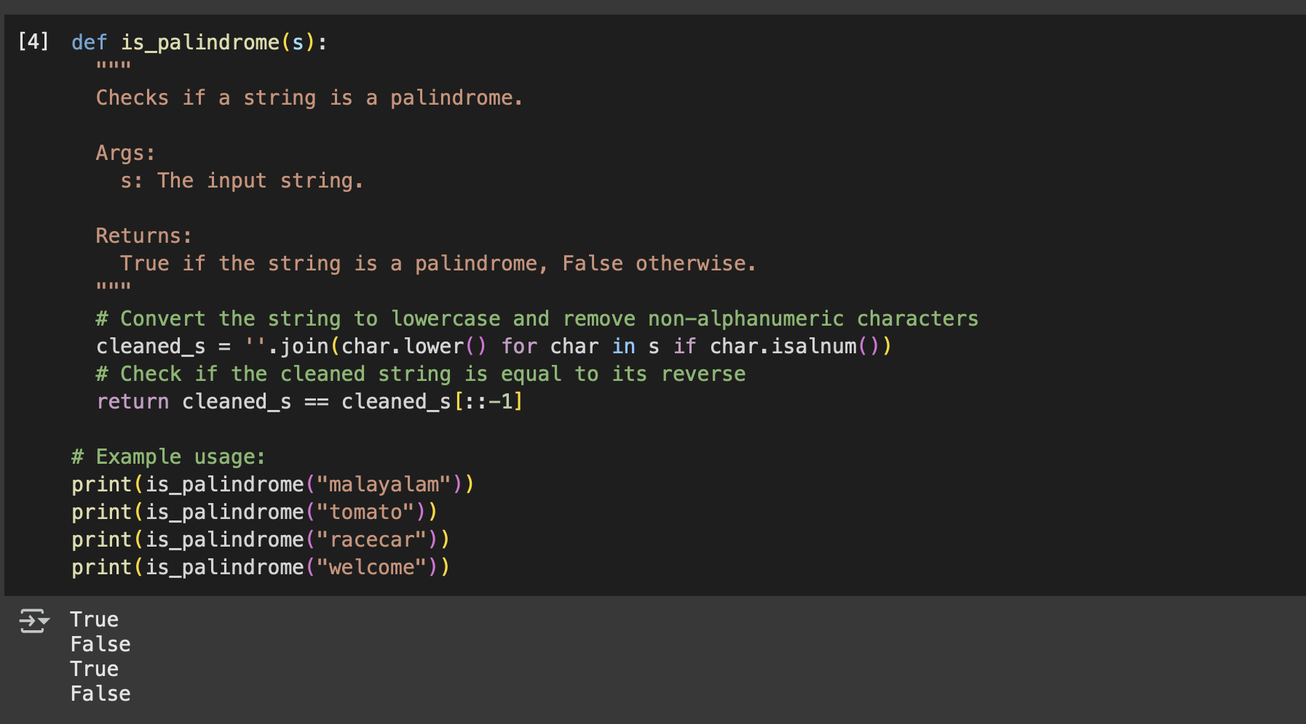

Explanation of the code: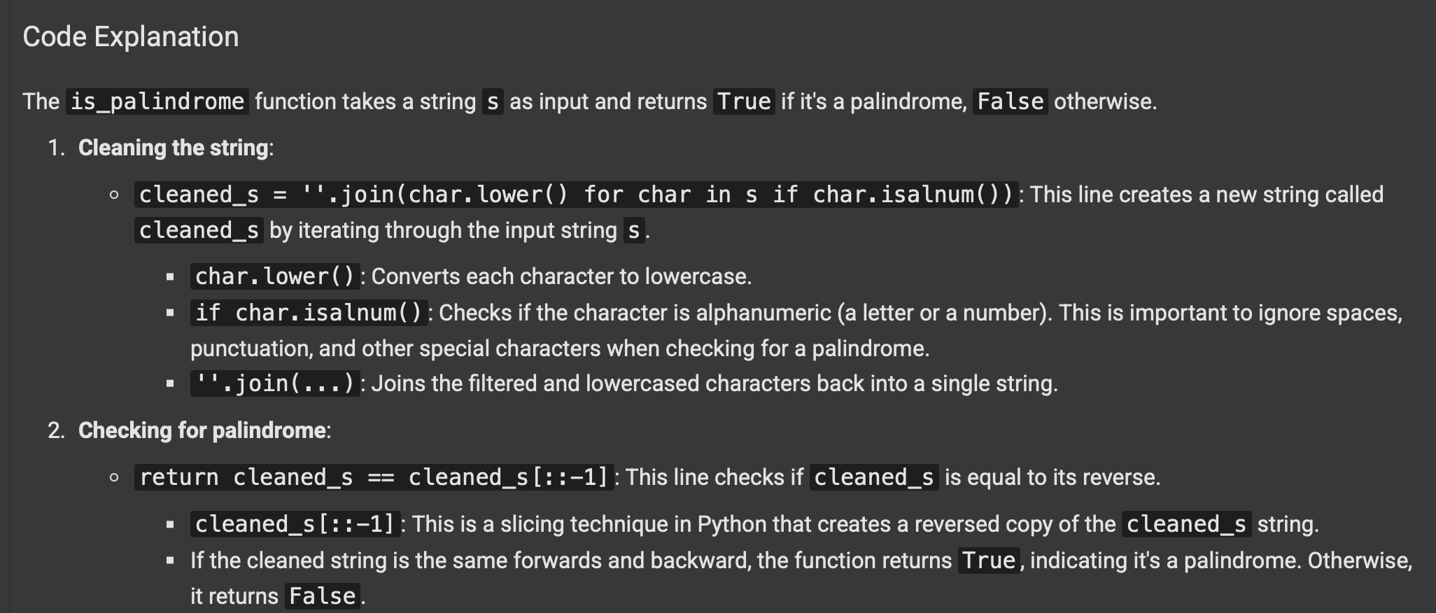

2.ask google copilot/gemini to generate a python program that finds the largest and smallest numbers in a user-provided list.Then,ask gemini to explain how the code works.

Code with output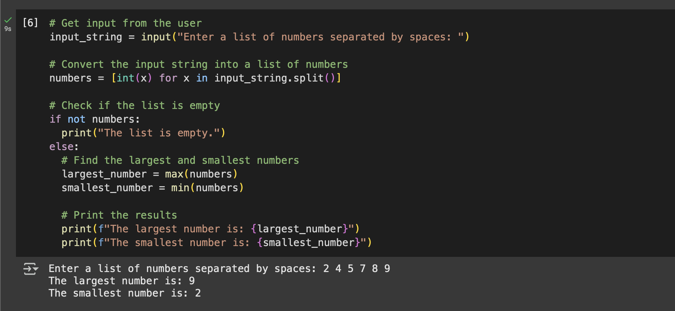

Explanation of the code:

